Surfing Through Change
Waves of Challenges
CCHRCO Annual Conference
August 22 – 24, 2021
Grande Dunes Marriott Resort
Myrtle Beach, SC

TENATIVE SCHEDULE OF EVENTS

Sunday, August 22, 2021

Registration………………………….….1:00 PM – 5:30 PM
Reception (Ticket required) ….….5:30 PM – 7:30 PM
Exhibit Hall

Monday, August 23, 2021

Continental Breakfast………..…....7:30 AM – 8:30 AM
Registration……………………..…...8:30 AM – 11:00 AM
Breakout Sessions……………..….8:30 AM – 10:00 AM
Morning Break………….………...10:00 AM – 10:15 AM
Breakout Sessions….….….….….10:15 AM – 11:30 AM
Lunch General Session……….…11:45 AM – 1:45 PM
Breakout Sessions………….…….…1:45 PM – 3: 00 PM
Afternoon Break……………..…..….3:00 PM – 3:15 PM
Breakout Sessions………….….…....3:15 PM – 5:00 PM
Exhibitor Reception (Ticket)…....5:30 PM – 7:30 PM

Tuesday, August 24. 2021

Breakfast (no service after 8).……7:30 AM – 8:15 AM
Business Meeting………….……...…8:15 AM – 9:00 AM
Breakout Sessions…………..…....9:00 AM – 10:15 AM
Morning Break………………...…10:15 AM – 10:30 AM
Breakout Sessions……….……….10:30 AM – 12 Noon

President’s Banquet…….………...…7:00 PM – Until??

Must have banquet exchange ticket.

Business Casual for Banquet attire.

Sam Bigby, Entertainer
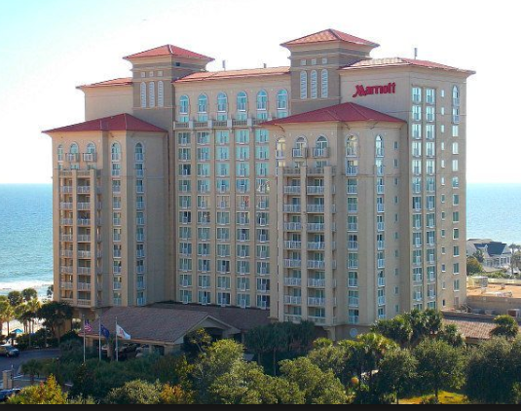

Myrtle Beach Marriott Resort & Spa
at Grande Dunes
8400 Costa Verde Dr, Myrtle Beach, SC 29572
(from Hwy 17, 82nd Ave North toward the ocean)

REMEMBER YOU MUST REGISTER FOR THE CONFERENCE BEFORE A ROOM WILL BE RESERVED. YOU MUST COMPLETE THE HOTEL RESERVATION FORM WITH YOUR REGISTRATION AND MAIL IN TOGETHER IF YOU WISH TO BE IN THE MARRIOTT IN THE CCHRCO BLOCK.

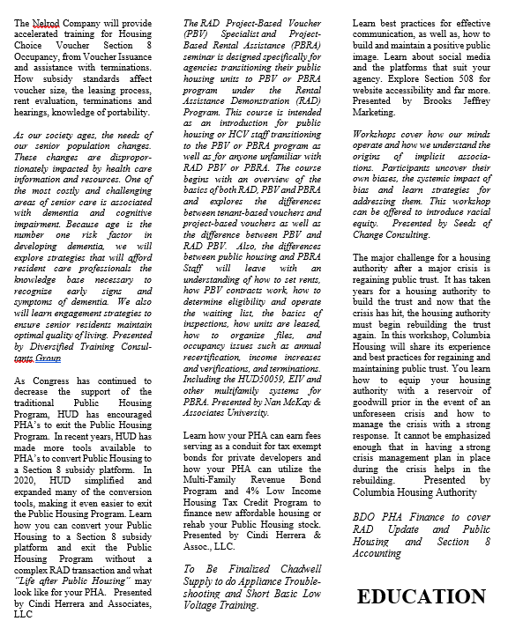
Cancellation Policy
All requests for refunds must be in writing or emailed to choward@fortmillhousing.com. Full refunds will made on written requests received before August 13, 2021; a $25.00 processing fee will be deducted from any refund.
No refunds after
August 13, 2021.
Last Day for Early Bird Registration is July 20, 2021 Register Early and Save $25.00.

CCHRCO
Housing Authority of Fort Mill
PO Box 220
Fort Mill, SC 29716

Check List
- Registration for Each Person Attending
- Hotel Registration for Each Room Required
- Golf Registration if attending
- Check for Registration Cost

Remember if you wish to have a hotel room at the CCHRCO block of rooms at the Marriott you must send in your registration and payment for the reservation to be completed. A confirmation will be sent to you a week to 10 days after receipt of the hotel registration.

